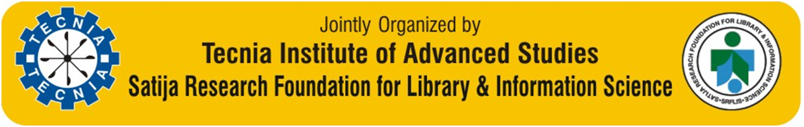
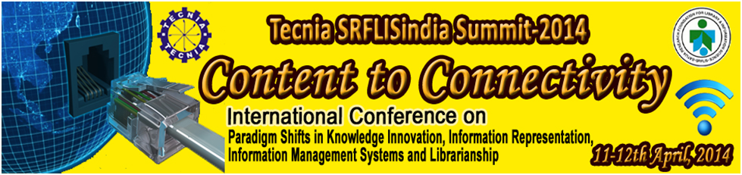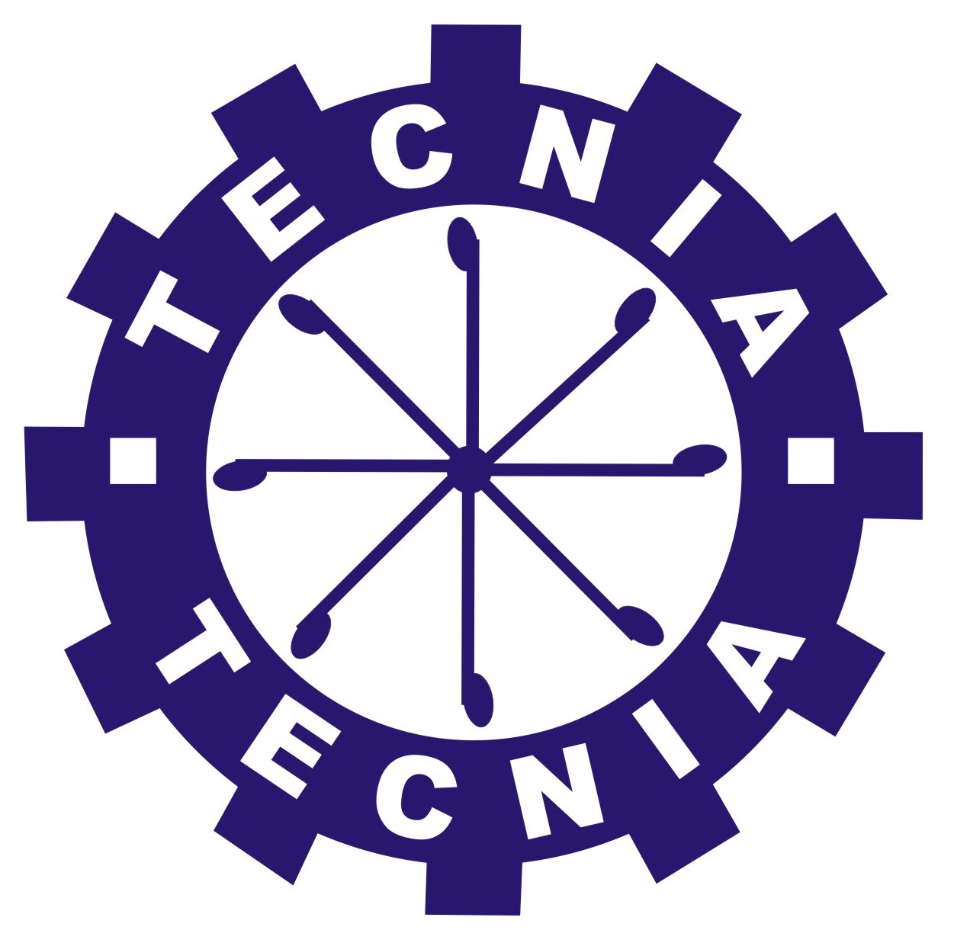
An ISO 9001:2008 Certified Institute; Recognized under Sec- 2(f) of UGC Act 1956; Rated as ‘A’ by Govt. NCT of Delhi ; “A++” Category - Best Business School by latest AIMA - Business Standard & Business India Publications Surveys & included in Top 100 B & IT Schools by Dalal Street Investment Journal
TECNIA INSTITUTE OF ADVANCED STUDIES
Approved by AICTE, Ministry of HRD, Govt. of India Affiliated To GGSIP University, Recognized under Sec 2(f) of UGC ACT 1956
INSTITUTIONAL AREA, MADHUBAN CHOWK, ROHINI, DELHI- 110085
Tel: 91-11-27555121-24, Fax No: 91-11-27555120,
E-Mail: directortias@tecnia.in; Website: www.tecnia.in

Date & Day
11th – 12th April 2014, Friday & Saturday

Venue
Tecnia Auditorium,
Madhuban Chowk, Rohini, Delhi-110085.

Tecnia SRFLISindia Summit 2014
INTERNATIONAL CONFERENCE
Content to Connectivity
Paradigms Shift in Knowledge Innovation, Information Representation,
Information Management Systems and Librarianship

Date & Day
11th – 12th April 2014, Friday & Saturday

Venue
Tecnia Auditorium,
Madhuban Chowk, Rohini, Delhi-110085.

4, Fax No: 91-11-2
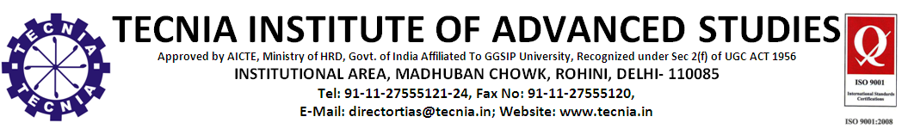

7555120,

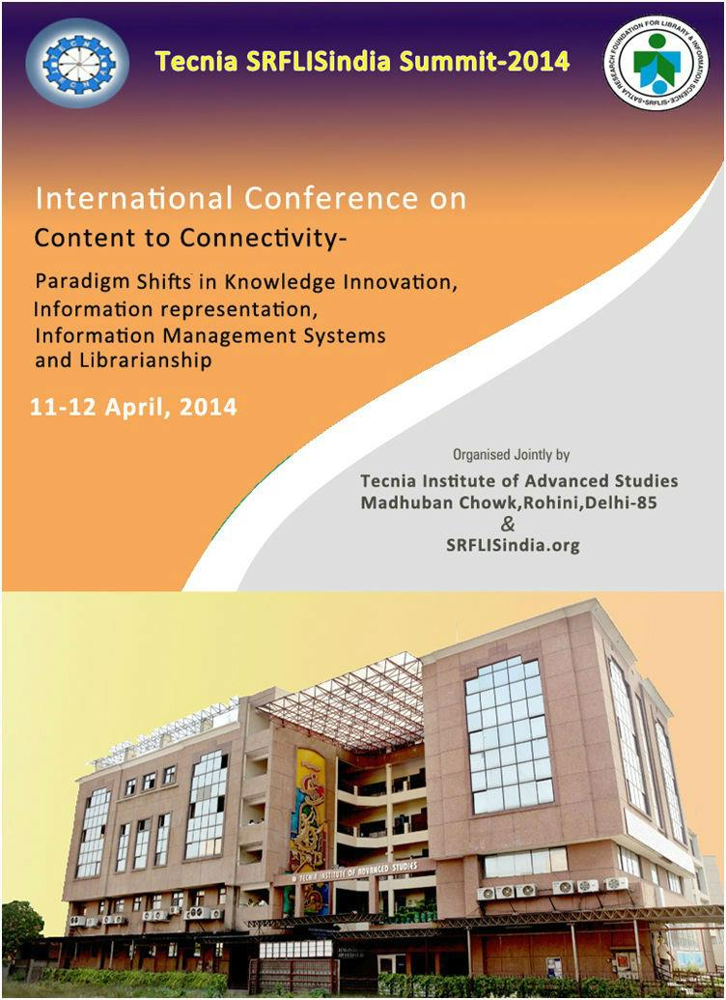

Tecnia Institute of Advanced Studies, Madhuban Chock, Rohini (Delhi) and Satija Research Foundation for Library and Information Science (SRFLISindia) are jointly holding an International Conference on the topic “Content to Connectivity- Paradigm Shift in Knowledge Innovation, Information Representation, Information Management Systems and Librarianship’.
The conference is being organized to bring together and provide a platform to Management, Information Technology, Library Information Sciences and Media Professionals, academicians, students and research scholars to present, discuss and exchange their experiences and expertise on the current issues pertaining to the theme of the conference.

Genesis

Today, organizations find themselves buried in structured and unstructured data, as the use of online data resources, mobile tools, and social networking tools spread, there is growing need to capture, manage and share content and knowledge in new ways. Organizations are looking for solutions to retrieve and manage their content; unfortunately, many organizations lack the systems to do so. There are many interfaces to share information and knowledge content among employees, customers and business partners. The world has become small due to connectivity, knowledge has become strong currency to trade between individuals and groups, which requires cross-functional planning and expertise through information technology and ultimately it promotes creativity. There’s no single tool or software package that captures the imagination of the organization to look into as one stop solution for storing and managing the contents and knowledge and to bring in compatibility between storage devices and human resources.

The main goal of ‘Tecnia SRFLISindia Summit-2014’ Content to Connectivity a two days international conference is to exchange ideas and find out different ways to manage knowledge contents and connect it to the world in more effective and efficient way. The ‘Tecnia SRFLISindia Summit-2014’ will explore different modes of available connectivity, which brings in new Paradigm shifts in knowledge Innovation, Innovation Representation, Information Management Systems and Librarianship.
The conference will provide an appropriate platform to all Academicians, Intellectuals, and Researcher and, Scientists for capturing & sharing expertise on:-

- Knowledge Management: - Knowledge management is a developing body of methods, techniques, tools, and values which organizations use to acquire, create, develop, share, transfer and apply knowledge to provide a return on their intellectual assets. For organizations to innovate – and thus sustain competitive advantage – requires the ability to quickly adapt to the business environment and save time-to-market. This adaptation requires learning, problem-solving, and the creation and integration of relevant new knowledge in response to business needs. The core components of KM – People, Process, Content and Technology, are the People component that is increasingly regarded as the lynchpin of successful organizational innovation.

- Information: - Information- as a concept has been considered and contrasted extensively with such terms as data, knowledge, and wisdom. On the other hand, the words information, text, and document are often used interchangeably in the field. No matter which format a piece of information may take, it needs to be rep- resented before it can be retrieved. Information representation includes the extraction of some elements (e.g., keywords or phrases) from a document or the assignment of terms (e.g., descriptors or subject headings) to a document so that its essence can be characterized and presented.

- Information Representation: - Information Representation-can be done via any combination of the following means: abstracting, indexing, categorization, summarization, and extraction. Information processing and information management, though having different meanings, are often regarded as synonyms of information representation. While information processing refers to how information is handled for retrieval purposes, information management deals with the full range of activities associated with information, from information selection to information preservation.
- Knowledge and innovation: Knowledge and innovation are inseparable from each other since they drive economies around the world. Knowledge producers and users endeavor to leverage the ideas, technologies, know-how and expertise on which their competitiveness depends. In simple terms, innovation is the application and transmission of knowledge from research to development and application. Now sharing knowledge through collaborative innovation has become increasingly important.

- Information Management System: - Information Management System (IMS) is a general term for software designed to facilitate the storage, organization and retrieval of information. It is a database and transaction management system that was first introduced by IBM in 1968. Since then, IMS has gone through many changes in adapting to new programming tools and environments.

- Librarianship: - Librarianship incorporates extensive revisions reflecting the increasing shift towards a networked and digital information environment, and its impact on documents, information, knowledge, users and managers. It offers a broad-based overview of the approaches and tools used in the structuring and dissemination of knowledge.

Objectives of the Conference

This conference intends to provide a forum for discussion and exchange of ideas on the main theme as well as the various themes. The main objectives of the conference are to:
- Develop a clear understanding on the role of IT, Management Science and LIS Professionals in Knowledge Innovation and Knowledge Management.
- Discuss debate and develop strategies to manage information systems and libraries in web environment.
- Identify and share ‘Best Practices’ developed and adopted by various information systems and libraries.
- Increase the expertise and provide the best possible platform by educating students and attracting new researchers.

Programme Structure

- Inaugural Session
- Technical Session
- Invited Lectures
- Product Presentation
- Report of the Summit
- SRFLIS Awards

Tecnia SRFLISindia Summit 2014
INTERNATIONAL CONFERENCE
Content to Connectivity
Paradigms Shift in Knowledge Innovation, Information Representation,
Information Management Systems and Librarianship

Key Issues, Themes and Subthemes

Knowledge Management, Knowledge Representation and Ontologies
- The Knowledge Society and Information Systems
- Knowledge and Ontologies in Information Systems
- Ontologies and Ontology
- Information Systems Knowledge Management and Engineering
- Enterprise Knowledge Management and Engineering
- Natural Language Processing
- Ontology Coupling, Integration and Matching
- Semantic Web Applications
- Knowledge Management
- E- Business and Internet Computing
- Management of Technology in Education and Businesses
- E-Government strategies, implementation procedures, and case studies
- Technology Transfer, Marketing and Commercialization
- Knowledge Engineering and Discovery
- Information Quality Metrics and Assessment
- E-Commerce issues, trends, and case studies
- Cyber law, E-commerce Law, and Intellectual property rights
- Customer Relationship Management (CRM),
- Supply Chain Management (SCM)
- Data Warehouses and Data Mining
- Software engineering of e-business systems
- Data Mining Techniques
- Knowledge extraction and search

Innovation and Entrepreneurship

- Innovation Clusters, Technology Transfer and Entrepreneurship
- Leveraging digital skills for Innovation in the Society
- Corporate and Social Entrepreneurship
- Women Entrepreneurs education and development
- Benchmarking of Entrepreneurship and Innovation Best Practices
- High Tech Entrepreneurship and Technological Innovation
- Strategic Integration between Innovation & Entrepreneurship

Tecnia SRFLISindia Summit 2014
INTERNATIONAL CONFERENCE
Content to Connectivity
Paradigms Shift in Knowledge Innovation, Information Representation,
Information Management Systems and Librarianship

Paradigms Shift in Librarianship

- Paradigms Shift in collection to content
- Development of E-electronic and Online Information Products
- CMS and Content Development
- Social Networking Sites and Libraries
- Information Communication Technology (ICT) and libraries
- Best Practices and Total Quality Management (TQM) in Libraries
- LIS Education and Curriculum Development
- Marketing of Library and Information Science Products
- Human Resource Management of Libraries
- Collaborative Knowledge Creation
- Mobile Technology and Service-Oriented Architecture
- Information and Communication Model
- Knowledge management best practices
- Information storage and retrieval system
- E-Resources Management
- Library consortia and Resource Sharing
- Institutional Repositories and Digital Libraries
- Open Source Software
- Open Access Scholarly Publishing

Important Dates

- Conference Dates: 11-12 April, 2014
- Submission of Full Papers: February 20, 2014
- Decision on Acceptance of Papers: February 28, 2014
- Camera Ready Copy and Registration: March 15, 2014

Tecnia SRFLISindia Summit 2014
INTERNATIONAL CONFERENCE
Content to Connectivity
Paradigms Shift in Knowledge Innovation, Information Representation,
Information Management Systems and Librarianship

Call for Papers
Original papers on the areas of interest are invited. The list is indicative and not exhaustive in coverage. The contributors may include any other topic under the broad categories of main theme of conference.

Submission of Papers

Papers on the theme listed above or any other issue related to the broad theme of the conference, based on research and practical experience in the field and case studies may be submitted for presentation. The authors should strictly follow the following structure and guidelines:

- Paper should clearly indicate the title of the paper (title case), name (s) of the authors, E-mail Ids, address of the affiliation of the authors with telephone number.
- Length of the paper should not exceeds 5000 words, single space, 10.5 point font size (Times New Roman or Arial), MS-Word.
- Abstract should not be exceeding 300 words, and should includes, methodology, sample of population and salient findings.
- Paper should have at least 3-4 Keywords.
- Strictly Follow the APA Style for Reference for references and cited work. The specimen for various kinds of entries of APA Style is reproduced for ready reference

- For book entry
- O’Donoghue, T., & Clarke, S. (2010). Leading learning: Process, themes and issues in international contexts. London: Routledge.
- For e-book entry
- Chaffe-Stengel, P., & Stengel, D. (2012). Working with sample data: Exploration and inference. http://dx.doi.org/10.4128/9781606492147
- For journal article entry
- Singh, K.P., & Satija, M.P. (2006). A review of research on information seeking behaviour of agricultural scientists: International perspectives. DESIDOC Bulletin of Information Technology, 26 (2), 25-36.
- For magazine article entry
- Borowitz, A. (2004, November 15). Pavlov's brother. New Yorker, 80(35), 63-66.
- For conference proceedings article entry
- Game, A. (2001). Creative ways of being. In J. R. Morss, N. Stephenson & J. F. H. Rappard (Eds.), Theoretical issues in psychology: Proceedings of the International Society for Theoretical Psychology 1999 Conference (pp. 3-12). Sydney: Springer.
- For websites
- Sea Turtle Restoration Project. (2006). Threats to sea turtles. Retrieved from http://seaturtles.org/section.php?id=104.
- Improve indigenous housing now, governments told. (2007). Retrieved from http://www.architecture.com.au/i-cms?page=10220
- For more details click
- http://www.apastyle.org/

- Authors are supposed to prepare PPT for the conference presentation and should send before attending the conference.
- The accepted papers for the authors, may submit ‘Certificate of Originality and copyright’ may be download (Create Link).
- Paper may be sent to ‘Organizing Secretary’ at the address given on the last page of the brochure and also copy to: tecniasummit2014@gmail.com. On or before February 20, 2014.
- Only Selected and registered papers will be published.

Tecnia SRFLISindia Summit 2014
INTERNATIONAL CONFERENCE
Content to Connectivity
Paradigms Shift in Knowledge Innovation, Information Representation,
Information Management Systems and Librarianship

Participants Profile

- Academic Fraternity in LIS, Management Science and IT
- Professionals working in academic, Industry and research concerned with IT, Management, LIS, health sciences & medicine, agriculture, insurance, banking, technology etc.
- Students and Researchers
- Knowledge Workers
- Publishers
- IT and Information Service Providers

Key Speakers

- Prof. (Dr.) Hamid Saremi, Vice Chancellor, Azad Islamic University of Iran, IRAN
- Dr. Bill Cope, Research Professor, University of Illionis, Urbana-Champaign, USA
- Prof. (Dr.) Shailendra Kumar, HOD, DLIS, University of Delhi, INDIAProf. AK Mitra, Dean, FMS, University of Delhi, Delhi
- Prof. AK Mitra, Dean, FMS, University of Delhi, Delhi
- Prof. Jagtar Singh, Dean and Head, Punjabi University, Patiala, Punjab
- Prof. (Mrs.) SP Singh, Head, DLIS, University of Delhi, Delhi
- Dr. PR Goswami, Director (Library), IGNCA, New Delhi
- Dr. Usha Munjo Munsi, Librarian, IIPA, New Delhi
- Dr. Ramesh C Gaur, Librarian, JNU, New Delhi
- Dr. RK Bhatt, DLIS, University of Delhi, Delhi
- Prof. Jaideep Sharma, DLIS, IGNOU, New Delhi
- Dr. Shantnu Ganguli, Head, Knowledge Resource Center, TERI, New Delhi
- Mr. Arvind Prasad, Ex-Head Geological Deptt.,TISCO, Jamshedpur

Tecnia SRFLISindia Summit 2014
INTERNATIONAL CONFERENCE
Content to Connectivity
Paradigms Shift in Knowledge Innovation, Information Representation,
Information Management Systems and Librarianship

National Advisory Committee

Chief Patron : Mr. R.K Gupta, Chairman, Tecnia Group of Institutes, Delhi
Co-Chief Patron : Emeritus Professor, MP Satija, DLIS, GND University, Amritsar, Punjab
Conference Director: Dr. Ajay Kumar Rathore, Director, Tecnia Institute of Advanced Studies, Rohini, Delhi.
Conference Director: Dr. KP Singh, DLIS, University of Delhi, Delhi.

Members
- Prof. K L Mahawar, DLIS, BBAU, Lucknow, UP.
- Prof. VT Kamble, DLIS, Gulbarga University, Gulbarga, Karnataka
- Dr. Narender Kumar, Librarian, IIT Delhi
- Dr. Nabi Hasan, Deputy Librarian, IIT Delhi
- Dr. Suresh Jindal, Director, DESIDOC, DRDO, New Delhi
- Dr. MP Singh,DLIS, BBAU, Lucknow, UP
- Dr. Ramesh C Gaur, Librarian, JNU, New Delhi
- Dr. Meera, DLIS, University of Delhi, Delhi
- Dr. Ravinder Kumar Sharma, Librarian, United Nations, New Delhi
- Dr. Subash Deshmukh, Libarrian, IP University, Delhi
- Dr. PK Jain, Librarian, Institute of Economic Growth, University of Delhi
- Mr. Manish Kumar, DLIS, University of Delhi, Delhi
- Dr. Sanjay Kataria, Librarian, JIIT, Noida
- Dr. Satya Prakash, Librarian , Asia Pacific Institute of Management, Delhi
- Dr. R. N. Malviya, Librarian, Lingaya,s, University
- Dr. S. B. Kulshreshtra, Librarian , MMH College, Ghaziabad, UP
- Mr. K. Nazeer Badusha, Librarian , Mohamad Sarthak Engineering College, Chennai
- Mr. Mange Ram, Librarian, Gautam Budh University, NOIDA, UP
- Dr. Sanjay Singh, Librarian , Galgotias College of Engineering & Technology, Greater Noida
- Mr. Deepak Shukla, Librarian , International Institute of Health Management Research, Delhi
- Dr. Durga Prasad, Librarian, SGIT, Ghaziabad
- Mr. Jaydeep Jedia, Librarian, SOIL, Gurgaon.
- Mr. Anand A. Jha, Dy. Manager, Knowledge Management, CMS, Delhi.
- Dr. Dharmendra Harit, Librarian, GIMT, Noida.

Organizing Committee

- Prof. Rajesh Bajaj
- Mr. S. C. Aggarwal
- Dr. Sandeep Kumar
- Mr. Anil Rajoria
- Mr. Vijay Singhal
- Dr. A. P. Singh
- Mr. M. N. Jha
- Dr. Namita Mishra
- Dr. Shipra Jindal
- Dr. Gurvidner
- Dr. Mani Manjari
- Mr. Sachin Sabharwal
- Mr. Aashima Sharma
- Mr. Anil Kumar Jharotia
- Mr. Harsh Mehan

Tecnia Institute of Advanced Studies

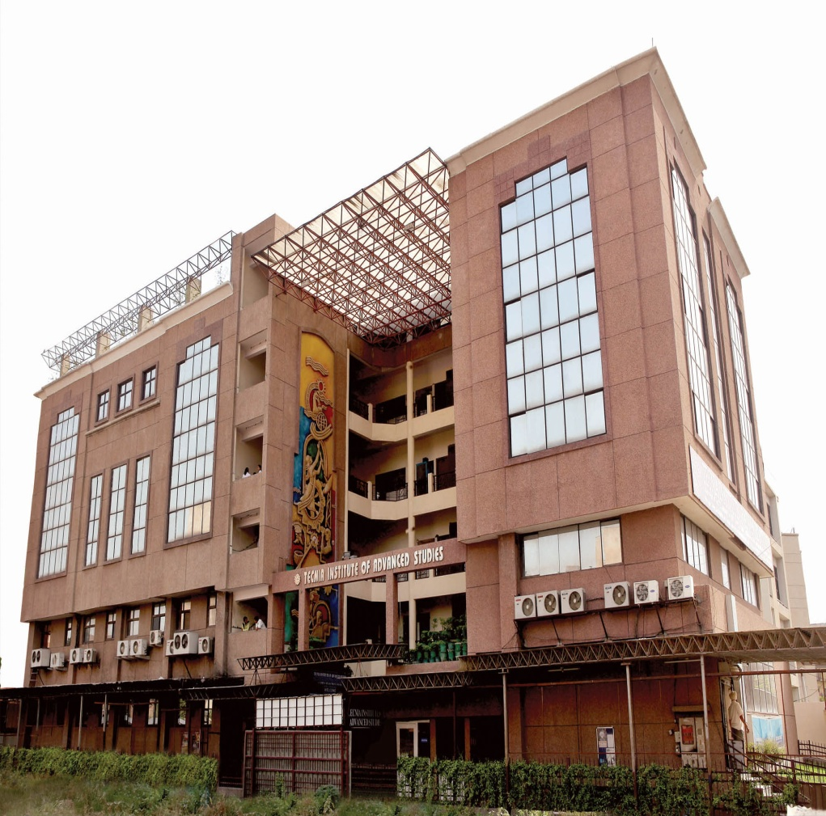
Tecnia Institute of Advanced Studies - A Flagship of Tecnia Group of Institutions, India’s Premier Management and Information Technology education Institution established by Health & Education Society, Delhi. Institute is approved by All India Council for Technical Education, Ministry of HRD, Govt. of India and affiliated to Guru Gobind Singh Indraprastha University, Delhi programmes since 1998. Institute Offers MBA Full Time & Part Time and MCA Full Time programme.

The Institute is situated in the country’s capital New Delhi – A Global Business Centre with multi- faceted society, an important educational hub of entrepreneurial influences and remarkable academic, professional and social opportunities. The Institute is well connected with Airport, Railways, Metro Railways and Mass Rapid Transport system at Madhuban Chowk, Rohini.

Institute is ISO 9001:2008 Certified by JAS-ANZ, Australia ensuring that our system and procedures are of a consistent quality, followed with precise rigidity. The Institute has been consistently ranked among the top B-Schools in the Country. TIAS features in 25 Top-Of-The-Mind Institutes by Mail Today B-School Survey and Rated as “A” Category Best Business School by latest AIMA – Business Standard & Business India Publications Surveys consistently year after year. Institute Ranked among Top 100 Business and IT Schools of India by Dalal Street Investment Journal.
Give Yourself the Edge of Excellence through Tecnia

The Institute has excellent ultra modern infrastructure including state-of-the-art Air Conditioned Library and Reading Room, Auditorium, Lecture Theaters, Tutorial Rooms, Seminar Halls, Computer Centre, Computer Laboratories with Audio Visual Aids for Presentations.

The Institute imparts Value Based Quality Education, Training, Research & Consultancy, in the field of Management and Computer Applications. At Tecnia, we bring together theory with hands on application, and it is this unique approach – action-based learning and interdisciplinary, team oriented situations – that develops leaders and ideas that change the world. The Institute offers the structure, the guidance, and the expertise, and students develop their own customized plan of action.

The Institute offers following electives in management stream Marketing, Finance, Human Resources Management, Information Technology and systems, Global Business Management. The students can also pursue electives e.g. Multimedia Technologies, Digital Signal Processing, Microprocessors, Fuzzy Sets and Logic, Compiler Construction, Distributors DBMS etc. in MCA Programme. The Institute has all the elements with which to transform future of the students and your career.

-: Contact at the following addresses:-
Dr. Ajay K. Rathore | Mobile: 91-9811229001 | Convener-Tecnia SRFLIS Summit-2014
Dr. K.P. Singh | Mobile: 91-9818057510 | Convener-Tecnia SRFLIS Summit-2014
Mr. Anil Kumar Jharotia | Mobile: 91-8468999379 | Conf. Secretary.-Tecnia SRFLIS Summit-2014
Tecnia Institute of Advanced Studies
PSP, Institutional Area, Madhuban Chowk, Rohini, Delhi-110085
E-mail: tecniasummit2014@gmail.com; directortias@tecnia.in
Phone: 011-27555121-22-23-24, Fax: 27555120

